Liyat Construction — website QR code
Opens: https://liyatconstruction.com
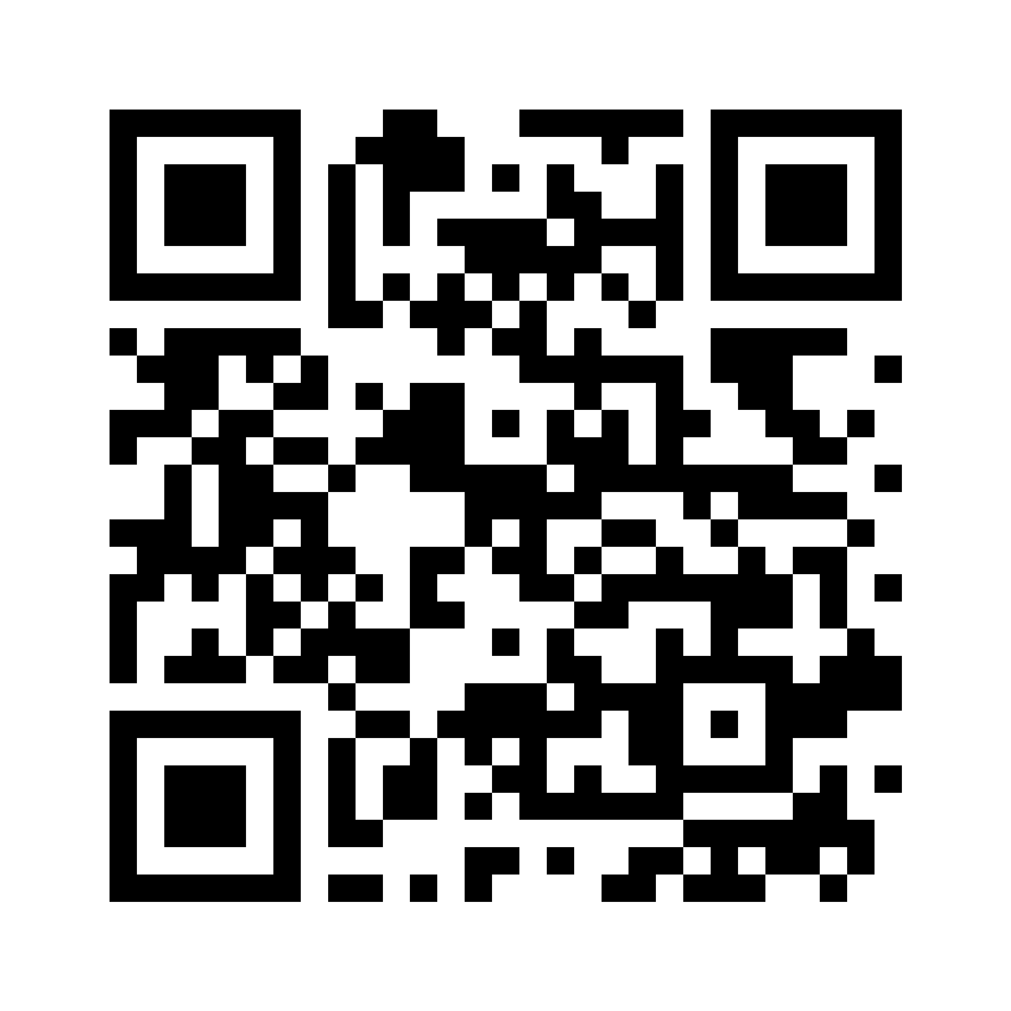
This is a static code: the address is inside the code itself. No QR service, account or subscription is involved, so it never expires. Scanning needs no internet; opening the website does.

Files
File | Use
liyat-qr.pdf | Print (vector, 60 × 60 mm page; scale freely, it stays sharp)
liyat-qr.svg | Print or design software (vector)
liyat-qr.png | Screens, slides, social media (2400 × 2400 px)
The white border around the code is part of it. Do not crop it.

Rules for the designer
- Size: at least 2 × 2 cm on business cards; larger on folders, banners and signs (rough rule: scanning distance ÷ 10).
- Colors: black on white as supplied. If recolored, only a dark color (e.g. Liyat green #156635 or Ink #1D2521) on white. Never light on dark.
- Background: plain white. Not over photos, patterns or textures.
- Do not stretch it, crop the white border, round the squares, add a logo in the middle or add effects.
- Label it: print the address under it, e.g. “Scan to visit us · liyatconstruction.com”.
- Proof: before the full print run, print one copy at real size and scan it with 3–4 different phones (iPhone and Android, new and old).

Before printing
liyatconstruction.com must be registered and the website live. Otherwise every printed code opens nothing.

Biniam Shimeles — Digital Aksumite
hello@digitalaksumite.com — www.digitalaksumite.com

